Example Snapshot WA8SME-7

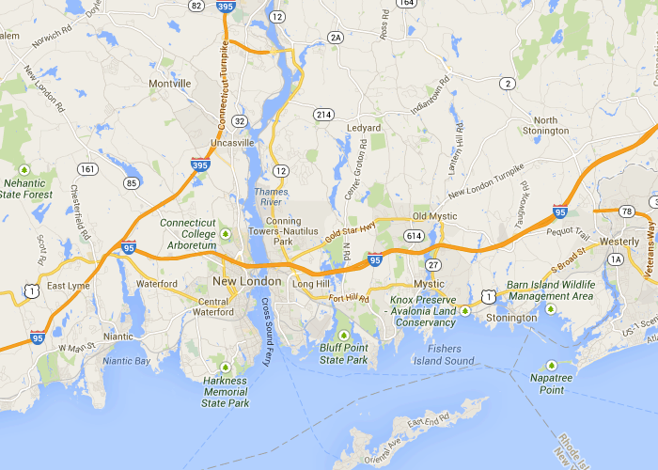
Position of WA8SME-7 --- 3.8 miles northeast of New London, CT --- Report received 4 hours 4 minutes 49 seconds ago
Status: MicroTrak FA v1.42I� Course: 191.0 Speed: 5.8 MPH Altitude: 111 feet Mic-E message 1, En Route
Raw packet: WA8SME-7>TQ2T5Y-2,SALECT,KB1JDX-15,WA1PLE-15,WIDE2*,qAR,N1EDF-1:`d]-lSwk/'"49}California Bound|#o&''f|!wKW!|3

