The OKC Memorial Marathon will be Sunday April 26, 2020. Again, this year we need 110+ Ham Radio volunteers. If you know anyone who is licensed and is interested in helping and has not received an invitation thru a radio club list, please give this email to them.
Below is the URL for registering for the 2020 OKC Memorial Marathon as a Ham Radio volunteer.
https://www.cuetoems.com/ocmm_2020/Volunteer.aspx?code=PSC2020
or - https://www.cuetoems.com/ocmm_2020/Volunteer.aspx?code=PSC2020 (copy and paste)
The first page is shown below. Please fill it and the following pages out as complete as possible. Your info is not shared with anyone.
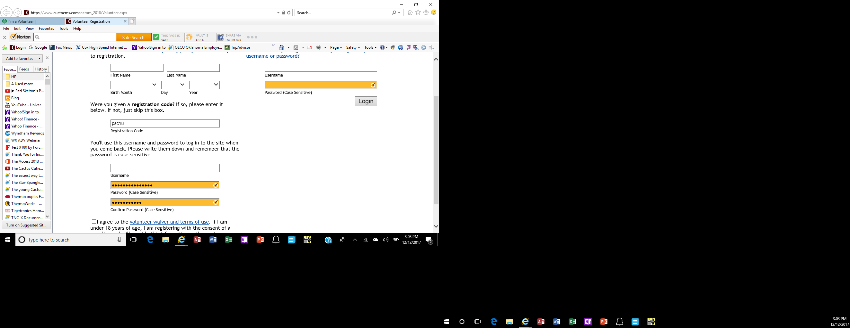
These will be blank – not colored
PSC2020
Create a user name and password you can remember so if you have to go in and update or correct something, you can.
Be sure to check the “I agree…..” box and there is a register or continue button just below what you see here.
It then takes you to a “Welcome screen. Read it and then click on “Click here to begin”. It asks for more info. Please fill it all out so you can be contacted by email or cell or home phone if necessary. Also, your shirt size, call sign, et,
There will be a ”previous experience” you can put in anything you want, the next page is for your shirt size, and then next is a schedule availability where you should check all day and if there is anyone you want to work with. This is where you can list family, friend, etc, (some who may not be lic’d but will work with you. That individual needs to register also). There is also a box for your call sign. Please fill it in. If you are someone who will be working with a licensed person be sure to supply that info also. That unlicensed person can put in your call sign.
It then goes to a fee page which should show $0.00. AND THEN YOU CAN LOG OUT AT THE TOP RIGHT.
You will receive an email asking to verify your email. Please do so.
Thanks so much for volunteering. If you have problems, please email me and I’ll get the IT folks at the office to help correct any problems.
IF YOU ALREADY REGISTERED AND DID NOT USE “PSC2020” PLEASE LET ME KNOW AND I’LL GET IT FIXED.
As much as possible I will try to assign you to the same place(s) as last year.
If you have other preferences, please list them and I will do my best to accommodate you.
There is a NO WEAPONS policy – open or concealed again this year for any part of the marathon.

