 | Arizona Section  Newsletter  January 2020 | 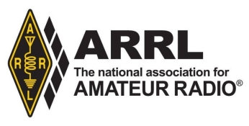

Arizona Section Manager, Rick Paquette W7RAP

Welcome all to the new decade of Amateur Radio in 2020
It was a great year in 2019. We continue to grow as fast as ever and increase our activities and effectiveness throughout the state of Arizona. We finished last year with 22,663 Amateurs and ranked 9th largest of all sections in the US. Moreover, we rank second overall in Per-Capita hams.

December concluded with a Super Superfest put on by the Superstition ARC, at Mesa Community College. Despite threatening weather, it turned out to be a beautiful day and many attendees and vendors regaled in Arizona’s spectacular sunshine. Early in January, the Thunderbird Hamfest was held in Glendale, AZ at their new venue. The weather was perfect and many Hams showed up to enjoy good swap items, and great indoor facilities for presentations and VE Testing. Prizes included a IC-7300 Transceiver and a Yaesu FT-8900R Transceiver.
The last week of January everyone trekked out to Quartzsite, AZ for the annual ARRL Specialty Convention “Quartzfest”. There were almost 1000 hams parked there all week long to enjoy and participate in the multiple ongoing events all day long. Quartzfest organizer Kriss Weed (KR1SS) and her staff kept everything running smoothly all the time. We were visited by three ARRL Division Directors and eight additional ARRL Officials. There were two VE Test sessions conducted, and many new upgrades and new Amateurs were welcomed into the fold Thanks to all the hard work the Quartzfest committee devoted, Everyone had a BLAST !!
View all the activities at https://www.facebook.com/groups/quartzfest/.

At the Quartzfest, There were presentations given by Dick Norton of the status of ARRL today and by Rick Paquette on ARRL-Arizona. The entire presentations are available for viewing at
https://www.youtube.com/watch?v=XtZvBRhRwx4&feature=youtu.be&fbclid=IwAR0zIta8IrRh1ScdBAiQy2BquQ1WLTa8JD8enmkh-lsIDEAbL1Q5tgCM-Y0
https://www.youtube.com/watch?v=Ik3mAYo0khY&feature=youtu.be&fbclid=IwAR2D8cMoZi40SHMcvZGjKKDnTOjEYpzur0J2VKOcXByVLfr29sjpCehS7Sc

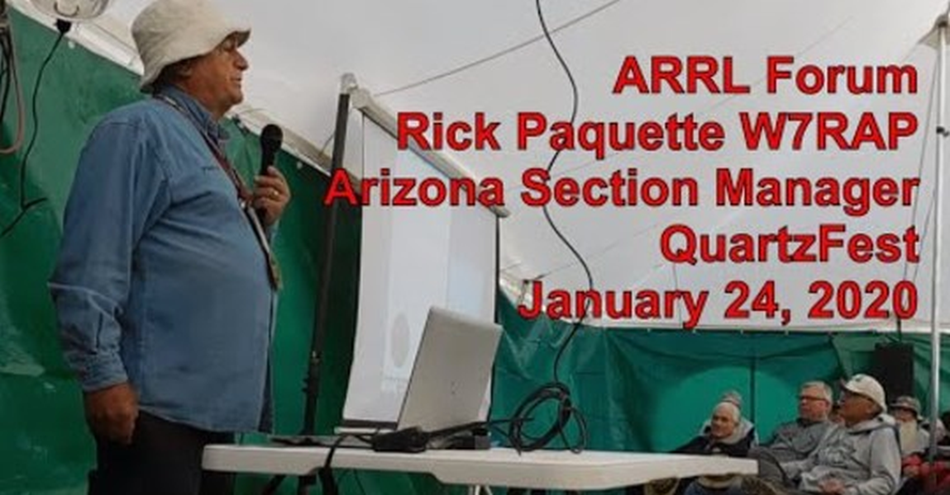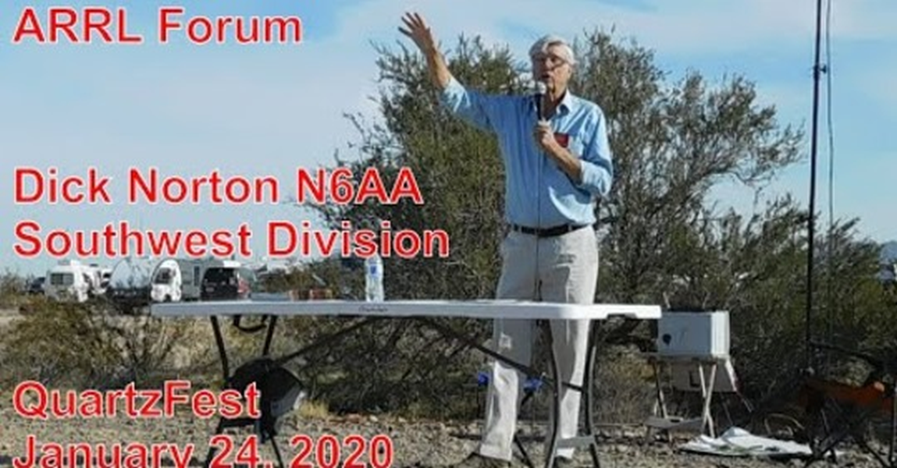

Upcoming Events:

Next up, on 14 and 15 February, is the ARRL Southwestern Division Convention being presented by the Yuma Hamfest committee headed by Jeff Weeks. Each year this event grows more, and this year we look forward to more than $27,000 in Grand Prizes and tons of activities. This year’s featured speakers include ARRL’s Riley Hollingsworth, head of the new Volunteer Monitor program, to talk about the changes from the Official Observer Program and how the new activities are being conducted. Fresh from the ARRL’s recent Board of Directors meeting will be our Southwestern Division Director Dick Norton (N6AA) who has lots of great news about changes and improvements in programs and some interesting new possibilities for us all. The special Event station this year will be W1AW/7 and there will be 3 Transceivers in operation. Come by the stations and get on the air. On Friday evening we will conduct the Secret “Wouff-Hong” ceremony to induct worthwhile amateurs into our most elite society. Plan on attending. Go to www.yumahamfest.org for all the activities and information
International DX Convention
Coming up is the International DX Convention in Visalia. A grand affair where you meet all those hams from around the world that you QSO with all year long. Many interesting talks and forums will be held and The banquets and social gatherings are outstanding. This year, the venue has returned back to the Wyndham Airport Hotel where all activities are held.
Visit http://www.dxconvention.org/index.html for all the details.

Section Emergency Coordinator, Dennis Bietry KE7EJF
Now is the time to review your family’s
preparedness. A great place to get information is the preparedness campaign at
www.azein.gov They will have weekly subjects; Plan, Prepare – Build A Kit, Inquire –
Be Informed and Inspire Others. Another place for information is www.ready.gov. Use
these sources and make sure your families are prepared. If they aren’t taken care of,
you can’t be a good communicator worrying about your family.
As I write this, many people on the East Coast are being required to test their
preparedness as Hurricane Dorian bears down on them. Think of this while reviewing
your own preparedness.
Dennis Bietry – KE7EJF/Section Emergency Coordinator / ke7ejf@arrl.net

Affiliated Club Coordinator, Mike Boger W7IJ
An application has been approved for the newly-formed Arizona VHF Society , with Jason Back (N1AV) as president and 11 new members. If you are interested contact the club at N1AV@ARRL.net

Technical Coordinator, Carl Foster KB7AZ
Many of the tasks previously performed under the Official Observer role here in Arizona, that are not being carried over to the new Volunteer Monitor program still need to be supported . These include : Monitoring frequencies for correct observance of Part 97 Regs, bandplan irregularities, and unintended emissions such as EMI and RFI and band edge issues. We still will support remediation in a non-enforcement role, as we have done under the Technical Coordinator activity. We are asking current and future OO’s to join our Technical Coordination activity, headed by Carl Foster.

New Hams and License Upgrades For December
It was another great month for New and Upgrading Amateurs here in Arizona.
86 New Hams this past month!
Particular congratulations go to all the VE Teams and Instructor Teams that keep us at the top of the list in Amateur Growth. Keep it up!!!! You are doing GREAT !!!
James | Hughett | KJ7KRN | G | Phoenix
Tony | Kramer | KJ7KGS | T | Phoenix
Andre | Lareau | KJ7KCD | G | Phoenix
Kristy | Szopinski | KJ7KRP | T | Phoenix
Lawrence | Szopinski | KJ7KRQ | T | Phoenix
Caine | Slezak | KJ7KRM | T | Phoenix
Herbert | Weil | KJ7KGR | T | Phoenix
John | Sikon | KJ7KCE | T | Phoenix
William | Trotter | KJ7KMY | T | Casa Grande
Christoff | Orr | KJ7KHN | T | Mesa
Nicholas | Dahlin | KJ7KBY | T | MESA
John | Raahauge | KJ7KUS | T | Mesa
James | Lannon | KJ7KMX | T | Mesa
Michael | Kanaly | KJ7KBZ | T | Mesa
Jean | Ledermann | KJ7KUU | T | Chandler
Chris | Mason | KJ7KUV | T | Chandler
Ronald | Chase | KJ7KUF | T | Gilbert
Michael | Willett | KJ7KGT | T | Scottsdale
Gary | Rasmussen | KJ7KCA | T | Scottsdale
Phillip | Carr | KJ7KJK | T | Fountain Hills
Suzette | Baker | KJ7KSO | T | Glendale
Linda | Foley-miller | KJ7KRO | T | Glendale
Martin | Alvarez | KJ7KCC | T | Glendale
Jeremy | Goodsell | KJ7KEC | T | El Mirage
Steven | Jacobson | KJ7KEB | T | Sun City
Kevin | Gates | KJ7KUT | T | Tonopah
Angel | Alvarez | KJ7KMU | T | Yuma
Raymond | Anderson | KJ7KCB | T | Peoria
James | Kempffer | KJ7KEA | T | Surprise
James | Mcgarvie | KJ7KUE | T | Payson
Pamela | Derks | KJ7KUH | T | Payson
Douglas | Laird | KJ7KUG | T | Payson
John | Mills | KJ7KJU | T | Benson
Jack | Mutchler | KJ7KHK | T | Hereford
Meck | Slagle | KJ7KJN | T | Tucson
Kathy | Hay | KJ7KJS | T | Tucson
Tommie | Slagle | KJ7KJM | T | Tucson
Rebecca | Hiser | KJ7KKS | T | Tucson
Gregory | Hiser | KJ7KKT | T | Tucson
Scott | Hunter | KJ7KJT | G | Tucson
Nicole | Quackenbush | KJ7KJQ | T | Tucson
Colten | Quackenbush | KJ7KJR | T | Tucson
Graham | Dektor | KJ7KMV | T | Tucson
Lola | Schwartz | KJ7KJP | T | Tucson
Stephen | Saltonstall | KJ7KKU | G | Tucson
Patrick | Timlick | KJ7KJO | T | Tucson
Alexander | Hawley | KJ7KJL | T | Flagstaff
Ted | Hench | KJ7LMK | T | Phoenix
Kenneth | Chambers | KJ7LGZ | T | Phoenix
Howard | Norman | KJ7LIN | T | Phoenix
Francisco | Luttmann | KJ7LIV | T | Phoenix
John | Paxton | KJ7LIS | T | Phoenix
Ronald | Logan | KJ7LIQ | T | Phoenix
Christopher | Dennison | KJ7LHB | T | Apache Junction
Ron | Sinclair | KJ7LHA | T | Queen Creek
Edward | Scheletsky | KJ7LEF | T | Mesa
Dwight | Duncan | KJ7LJU | T | Mesa
Conor | Mcbarron | KJ7LJV | T | Chandler
Cody | Mcdowell | KJ7LJW | T | Gilbert
Kyle | Eastman | KJ7LLB | T | Chandler
Paul | Rost | KJ7LBV | T | Sun Lakes
Matthew | Wenzlau | KJ7LEH | T | Scottsdale
Kurt | Von Rice | KJ7LIX | G | Scottsdale
David | Sirof | KJ7LMJ | T | Scottsdale
Ernest | Smith | KJ7LJX | T | Fountain Hills
Zhenyu | Mao | KJ7LDX | T | Tempe
Aaron | Myers | KJ7LHC | T | Tempe
Alan | Short | KJ7LGY | T | Gilbert
Christopher | Pagador | KJ7LIT | T | Glendale
Aidan | Hammer | KJ7LMI | T | Glendale
Brandon | Curry | KJ7LIR | T | Buckeye
Howard | Brown | KJ7LCG | T | Quartzsite
Albert | Shelton | KJ7LMG | T | Wellton
Christopher | Baker | KJ7LIY | G | Peoria
William | Concentine | KJ7LIU | T | Goodyear
Santiago | Rodriguez | KJ7LIW | T | Goodyear
Ernest | Junkert | KJ7LEN | T | Payson
Marilyn | Fontaine | KJ7LCO | T | Oracle
Dillon | Gugler | KJ7LEL | T | Sahuarita
Tyler | Berg | KJ7LCM | T | Tucson
Mark | Baker | KJ7LEK | T | Tucson
Kyle | Johnston | KJ7LCN | T | Tucson
William | Hofhine | KJ7LEM | T | Tucson
Jonathan | Annua | KJ7LEY | T | Tucson
Gregory | Mosier | KJ7LEZ | T | Tucson
Marci | Bunnell | KJ7LBT | T | Blue

Congratulations also, to the 19 hams who have recently upgraded their license.
Shaun | Lawson | KJ6VGQ | G | Apache Junction
William | Borden | KJ7KQQ | G | Tempe
Dean | Sawyer | KI7JRD | G | Buckeye
Robert | Conlin | KJ7JNR | G | Peoria
Russell | Kinner | WA8ZID | E | Surprise
Daniel | Pinda | KJ7JFE | G | Tucson
Edward | Taylor | KJ7DTA | G | Tucson
Kaelan | Strones | KJ7HWZ | G | Flagstaff
Kenneth | Smith | KJ7DJM | G | Queen Creek
Robin | Tapelt | KJ7JAJ | E | Mesa
Charles | Allred | KF7FNZ | E | Mesa
Glenn | Hunt | KJ7JNQ | G | Glendale
Gabor | Morocz | KM6JSR | E | Oracle
Douglas | Gugler | KC7OVN | E | Sahuarita
Jeffrey | Mcconnell | KJ7JFF | G | Tucson
Edward | Linehan | KB7RVM | E | Tucson
Gilbert | Mcclung | KJ7KYZ | G | Tucson
Graham | Dektor | KJ7KMV | G | Tucson
Warren | Yerkes | KI7YJV | G | Kingman

Upcoming Hamfests and Events

Search for ARRL sanctioned hamfests: http://www.arrl.org/hamfests-and-conventions-calendar
See upcoming hamfest fliers attached at bottom of this newsletter.

Amateur Radio Classes
Find upcoming classes: http://www.arrl.org/find-an-amateur-radio-license-class

Amateur Radio Testing
Search for upcoming Amateur Radio exams: http://www.arrl.org/exam_sessions/search

Arizona Test Sessions
Phoenix area:
- 1st Saturday 9:00AM - DeVry/West Valley Club (Walk-ins allowed) Contact David, N7TWT (623)925-0680 Email: N7TWT@ARRL.NET Location: De Vry University 2149 W Dunlap Ave PHOENIX, AZ 85021
- 2nd Wednesday 6:30PM - Central Phoenix VE Team- Location: South Mountain Community College (Library) (No walk-ins) Contact: Bill Martin (480) 205-3625 (480) 205-3625 Limited space, you must contact Bill. Email: ai0d@hotmail.com
- 2nd Tuesday of each month- East Valley VE Team 6:00 PM (Walk-ins allowed)
VEC: ARRL/VEC Location: Charles K. Luster Building (Formally known as City of Mesa Utilities)
640 N Mesa Dr Mesa AZ 85201-5104
Contact: Fred C. Bollinger (480) 242-8606 Email: fredbollinger@gmail.com
- 3rd Tuesday 8:00PM - BOY SCOUT TROOP 127 (Walk-ins allowed) Contact: John H Kelly (602)264-6854 Email: KELLYJ127@AOL.COM
Location: ST Francis Xavier School, 4715 N Central Ave Phoenix, AZ 85012

- Last Sunday 7:00PM - Arizona Amateur Radio Club (No walk-ins) Pre-Registration Required
Location: 4747 N. 22nd Street, on the eastside of 22nd Street and just north of Highland Ave. in Phoenix. Notify Gary By Thurs Nite, Contact Gary Hamman, K7GH (602) 996-8148 Email: K7GH@ARRL.NET

- 3rd Wednesday 6:00 PM - The Thunderbird ARC offers tests at no charge to the public
Location: Honor Health Medical Office Bldg. 19841 N. 27th Ave, Phoenix,
Contact: Briam Mc Carthy 623 486-0507 ve@w7tbc.org.
Tucson Area:
- 1st Thursday - Lighthouse YMCA/ARRL. Contact Matt, AC7IL, veregistration@ac7il.org
- 1st Saturday - Oro Valley/ARRL. Contact Quinton, NU7Y, nu7y@arrl.net
- 2nd Monday - RST/ Laurel (No Fee): Contact Diane, AA3OF, dzimmerman2002@gmail.com

Graham / Greenlee County Area:
- For VE testing on request, please contact Dave, N7AM, and he will arrange it.

Yuma Area:
- 2nd Saturday - By appointment only. Contact Sam Yarbrough W7SLY at: W7SLY@roadrunner.com or Robert Spencer KE8DM at: ke8dm@arrl.org

Arizona Nets

The following weekly and daily nets have been added to the QCARC NET Calendar:
- Hassayampa Amateur Radio Klub (HARK) Net, Tuesdays @ 1930 Local
- Daily Arizona Weather Net (DAWN), Daily @ 0600 and 1600 Local
- Chandler Ham Radio Club, Thursdays @ 2000 Local
- AM 2 Meter Net, Tuesdays @ 1930 Local
You can find their calendar at: http://queencreekarc.org/index_files/Page589.htm
Please submit any additions, corrections or comments to. Joe, N2QOJ at jsammartino@gmail.com

Arizona Traffic and Emergency Net (ATEN) meets in the winter from October 15 to April 15 at 5:30 PM and in the summer from April 15 to October 15 at 7:00PM on 3986 kHz daily. Tommy Ivan KF7GC Net Manager, Arizona Section Traffic Manager kf7gc@arrl.net www.atenaz.net

Arizona Emergency Net – Maricopa (AEN-MAR) meets every Monday at 9:00 PM local time, for training and exercise in the public service communication arts on the following six linked repeaters. Shaw Butte 147.24 (plus offset), Mount Ord 146.92 (minus offset), Scottsdale Airpark 146.76 (minus offset), Usery Pass 146.86 (minus offset), Mingus Mountain 146.82 (minus offset), and Daisy Mountain 448.375 (minus offset). All of the 2-meter repeaters require a 162.2Hz tone and the 70-centimeter repeater requires a 100.0Hz tone. The repeaters are linked and cover most of Maricopa County and portions of Pinal, Gila, Coconino and Yavapai Counties in central Arizona. http://www.aen-mar.org

Saguaro National Traffic System (NTS) Net (www.saguaronts.net), meets daily at 6:30 pm MST (0130Z) on the Eastern Arizona Amateur Radio Society (E.A.A.R.S.) (http://www.eaars.org/) repeaters. The repeaters are; 146.86 and (440.700 Hub) Heliograph Peak 147.28 Guthrie Peak - Greenlee County 145.21 Jacks Peak New Mexico. Between Lordsburg & Silver City 145.41 Pinal Peak Near Globe AZ 147.16 Mt Lemmon Near Tucson 146.70 Greens Peak Near Springerville - Showlow 145.27 South Mtn. Near Alpine, AZ 147.08 Mule Mtn. Near Bisbee in Cochise County 147.06 Lil Florida Mtn. Near Deming, New Mexico 145.47 Caballo Mtn. Near Truth or Consequences, New Mexico 145.35 West Peak. West of Heliograph 12 miles All E.A.A.R.S. network repeaters operate with PL tone 141.3. For more information about this net, contact Greg Peters (kc5zgg@arrl.net)

AM 2 meter net Greater Phoenix Metropolitan area, 2 meter AM net, 144.450 MHz, every Tuesday night at 1930 MST. Antenna vertical polarization. The 144.450 MHz is a coordinated AM frequency in Arizona. This is an informal NET, most discussions are technical. All are welcome.

